

**Report of Evidence**

**Team Collaboration:**

We utilized various channels such as Basecamp, Gmail, WhatsApp, and Microsoft Teams for appropriate collaboration and communication.

Screenshots and photos uploaded reveal continuous discussions, assigned tasks, and work on the projects.

Documentation of active involvement in discussions, task delegation, and decision-making with the aid of Basecamp, GitHub, and other resources.

**Working in Class**

Evidence of in-class work is presented in the form of photos displaying collaboration, code reviews, and problem-solving activities.

The group worked together in person, focusing on the key areas of the project and coming up with solutions successfully.

**Documentation and Coordination:**

Meeting minutes, email chains, and chat transcripts showcase flawless coordination and task flow during the project.

Thorough documentation of the requirements, implementation, and issues was achieved through GitHub, Basecamp, and Microsoft Teams.

**Evidence for Procedures (CDP01, CDP02, CDP06, CDP09):**

Attendance Procedure (**CDP01**): Regular attendance at classes and meetings confirmed by attendance register and photos.

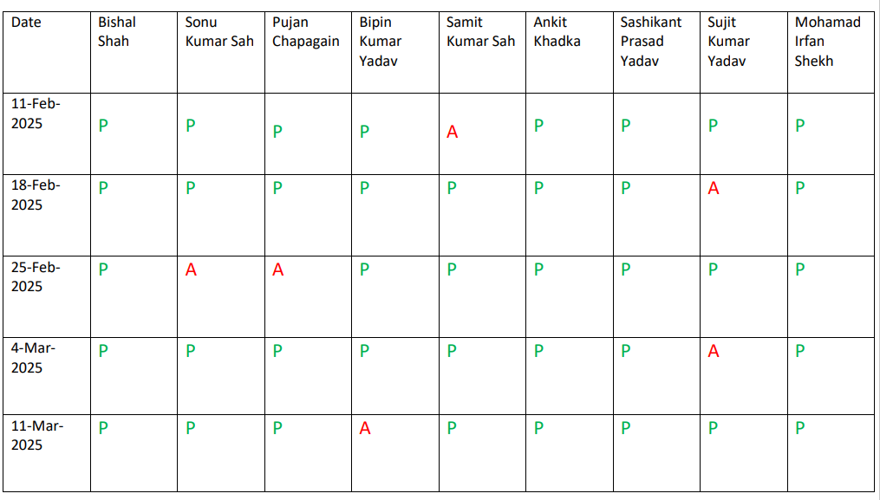

Software Engineering Process (**CDP02**): Chosen technologies described in the Technology Justification Report, code excerpts, commit history, and GitHub contributions.

Collaboration Procedure (**CDP06**): Proof of continued collaboration through Basecamp, GitHub, and team meetings.

Security Testing Procedure (**CDP09**): Evidence of security testing in the form of screenshots, GitHub issues, and test reports.

**Personal Goals and Demonstrations of Skills:**

Objectives such as technology selection, code generation, debugging, collaboration, and security testing are illustrated during the project. Personal skills demonstrated are problem-solving, coding, teamwork, and procedure following.

**Here is the spme screenshots and photos;**

